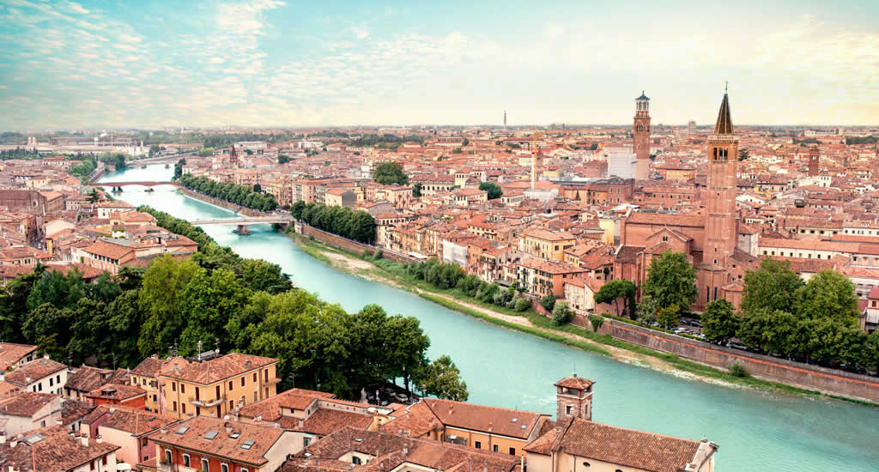
DOCE VERONA MEETING
ASSIGNMENT

Assignment:

Each team creates a digital lesson of 30 minutes. This lesson could be an online lesson with a teacher or a downloadable lesson which will take about 30 minutes to follow.
The lesson must be about a cultural or creativity topic of Verona.
Each team has a specific location in Verona. This location itself, or something at the location in particular, must be illustrative (exemplary) or representative for your topic.
A kind of assessment must be a part in your digital lesson. Maximum time for this assessment is 7 minutes.

Aim:
- Make the students aware about the cultural impact of your topic.
- Create curiosity at the students about your topic.
- The contribution to the results, of every single member of your team, must be described in one sentence.

Target group:
Students in the age between 17 and 22 year who are following a creative course at your school.

Final result:
A digital and downloadable lesson.

Extra information:
- Each team will have a “creative guide” who can help you in your creating process. You can call this guide for help.
- Each group will have a “information guide” who knows where you can find more information. This guide will be with you on Wednesday afternoon and Friday morning.
- The experts in your teams are responsible for the quality of the results.

Schedule:
Thursday
12:30 Lunch in the different teams. Sharing ideas during lunch.
13:30 Set up a brief idea about your digital lesson and present it to your guide(s). Your guide will give you feedback. (The coordinators are the guides and if possible, also some students from Verona who have the local information. Share phone numbers. Share your location in Whatsapp)
14:00 Go with your team to the location to collect footage, photo’s, information, etc.
16:30 Back at school for sharing the information with the others.

Friday
09:00 Start of the day with a presentation by the guide (pictures?) of what they have seen in the day before. 5 to 10 minutes per team.
10:00 Work on the digital lessons. Deadline 12:30
12:30 lunch
13:30 Presentations of the digital lessons. Maximum 15 minutes per group. 5 minutes per group for tips and tops.
15:30 Wrap up and goodbye.

6 international mixed teams. 6 Locations.

Group Porta Borsari. Guide Nick Jordan.

Group Piazza dei Signori. Guide Susana Bronze.

Group Duomo di Verona. Guide Daniel Kehl.

Casa di Giulietta. Guide Raul Martinez.

Piazza delle Erbe. Guide Toni Essel.

Verona Arena. Guide Sander Spek.

